Role Profile

Job Title | Head of IMS
Job Family | Business Improvement & IMS
Grade | 3
Reporting to | Director of Business Improvement & Integrated Management System (IMS)
Purpose of role | Develop and implement the business HSEQ strategy and long term business plans, whilst cultivating a culture of safe behaviours, quality assurance and continuous improvement.  Working at strategic level, provide support and influence Senior Management with an approach that balances best practice and commercial thinking.  Manage a geographically dispersed team of HSE Managers who can inspire and motivate others, ensuring engagement and adherence to legislation and internal policies / procedures and take overall responsibility for the development, review, implementation and maintenance of the MSPS’ Integrated Management System (IMS)
Morgan Sindall Group

A leading UK construction and regeneration group, operating in the public and commercial sectors, through six divisions of construction and infrastructure, fit out, property services, partnership housing, urban regeneration and investments.

Property Services Overview

Morgan Sindall Property Services Provides integrated property maintenance services to both the public & private sector, with particular experience in housing and public building maintenance. We provide planned and reactive maintenance to over 200,000 domestic properties nationwide and have a significant portfolio of large-scale framework refurbishment programmes. We refurbish and modernise approximately 10,000 homes per year and complete in excess of 300,000 repairs per year.

Job Family

The Business Improvement & IMS job family contains roles that deliver Continuous Improvement, Projects, and HSEQ within the business.

Key Responsibilities

- Engaging at all levels of the organisation from Board level to site, ensuring the HSEQ strategy is effectively communicated and successfully implemented.
- Promote HSEQ best practice nationally supporting the business to ensure legal and corporate compliance.
- Manage changes to the IMS and business systems to support business changes and market requirements.
- Manage and maintain audit compliance with the IMS, Group and ISO certification.
- Management of business risk information internally and externally.
- Support the Director of Business Improvement & IMS in balancing the interests of shareholders, employees, clients, customers and other stakeholders, ensuring good profitability and supporting the delivery of the 5 year strategic business plan.
- Abide by, and work within, the spirit of the MSPS Good Governance Charter and MSPS Values.
- Leading the HSEQ team and support the business as HSEQ subject matter expert in business integrations, transfers, and acquisitions.
- Develop, manage and coordinate the execution of business wide HSEQ programmes to address risks, impacts and effectiveness across the division, whilst promoting compliance, standardisation and best practice.
- Responsible for implementing company HSEQ policies and procedures; and via regional teams recommend improvement plans to support and follow implementation.
- Ensure accidents and incidents are investigated and preventive measures circulated throughout the business to avoid recurrence.
- Advise the Directors / Board on all important Health, Safety, Environmental and Quality Assurance issues, inclusive of legislative matters, that affect business activities.
- Ensure the IMS is fully adhered to and ISO registration is maintained through HSEQ compliance
- Across the business develop and implement initiatives to improve technical and behavioural skills with HSEQ / compliance.
- Comply with the company HR values, policies and procedures, ensuring that at all times behaviour is fair and non-discriminatory.

- Provide strong leadership and support to the HSEQ Team.
- Develop the HSEQ Team to provide mentoring and support all employees.
- Act as a role model for leadership positions, and proactively challenge behaviour and actions that may adversely affect employee or customer health and wellbeing.
- Keep abreast of HSEQ legislative compliance, standards and best practice, through a wide range of internal and external networks to benefit future growth.
- Working closely with key stakeholders, seek out and trial potential cost effective products or procedures that will reduce risk to all those involved.
- Develop the overall strategy of continuous improvement, drawing on findings / failings from internal audit reports and industry best practice.
- Instigate and support Health, Safety, Environmental and Quality Assurance improvement / communication initiatives.
- Develop internal HSEQ training programmes for relevant employees, drawing on various delivery methods / applications.

Behavioural Requirements

- Excellent communication skills both written and oral.
- Ability to build both strong client and internal relationships at all levels.
- To be self – motivated, innovative, and able to develop ideas and initiatives.
- Ability to lead, facilitate and co-ordinate various functional activities.
- Ability to work in a collaborative manner and with teams.
- Significant leadership, change, and project delivery experience.
- You will have highly developed interpersonal communications skills and cultural sensitivity and be able to motivate a geographically dispersed team; as well as build effective relationships across the business.
- You will have a pragmatic and proactive approach to HSEQ management, with the ability to build strong relationships in order to influence and engage at all levels of the business to ultimately deliver a strong HSEQ culture.
Qualifications, Experience and Skills

- Expert in the requirements of ISO Standards 9001, 14001, 18001, 45001 (Integrated Management System)
- Preferred understanding of the R&M, Planned sector and technical / compliance services and operational requirements.
- The NEBOSH Construction Certificate and Diploma (or equivalent) is required as a minimum.
- Chartered Member of IOSH is strongly preferred.

- From a similar senior leadership position, you will have experience of driving HSEQ standards and performance across multi-site operations as well as leading an innovative and highly skilled HSEQ team within a specific business unit
- You will have a demonstrable track record of creating and implementing innovative HSEQ strategies.
- Ability to produce factual, clear and concise reports
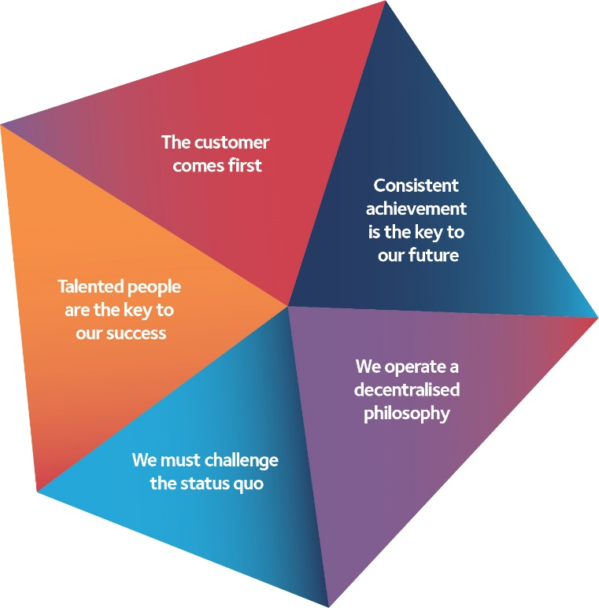
- Strong project & change management skills are a pre-requisite. You must be able to suggest and recommend alternative ways of operating and implementing changes which add value and benefit to the business.
- Full UK driving license is required as you will be expected to be an active presence on site and office locations throughout the region.

